5.1 Vector Field Worksheet

- Sketch the vector field .
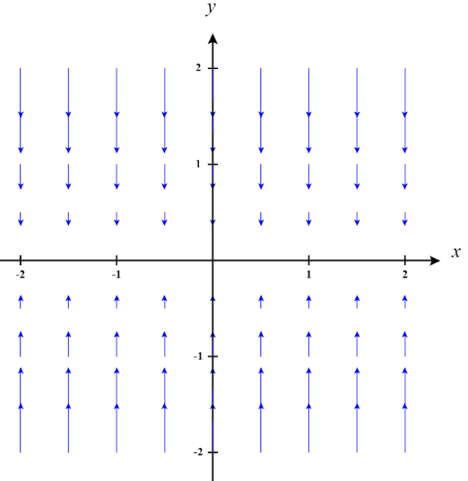

- Let . Sketch the vector field

First, we calculate that .
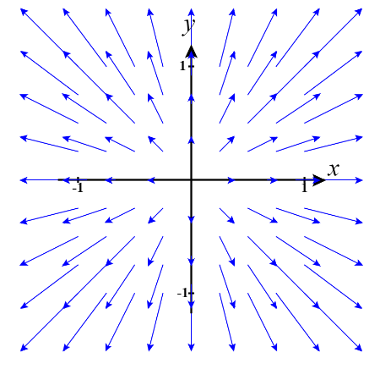

- Sketch the vector field .

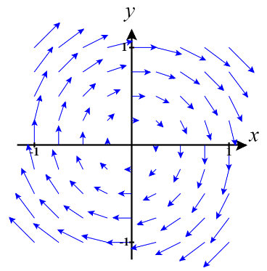

- Compute the gradient vector field of f, where
First, we calculate that .

- Three vector fields are shown below. Which of the vector field corresponds to ?
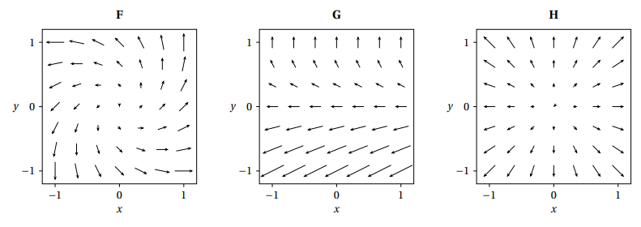

We see that .

- Here are plots of 6 vectors fields on the box where , , and . Which of the following vector fields corresponds to the vector field ?
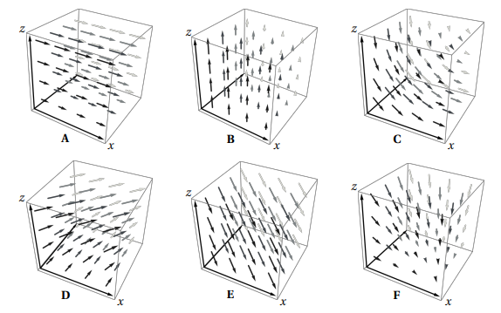

It should be the case that the vectors should be parallel to the xy-plane. The x component should increase as z values increase, and y values should be 1 for each vector. We can see that D meets this description.

- Here are plots of 5 vectors fields on the box where , , and . Which of the following vector fields corresponds to the vector field ?
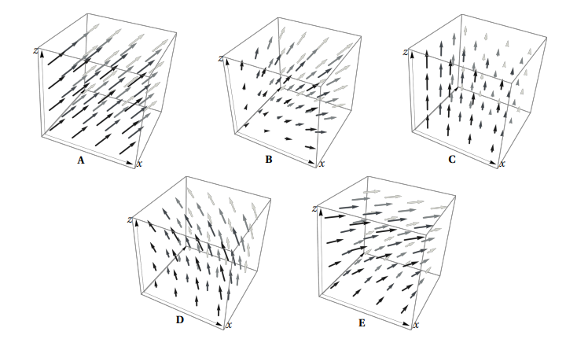

It should be the case that the vectors should be parallel to the xz-plane. The x component should decrease as z values increase, and z values should increase as x values increase. We can see that D meets this description.

- Determine if the vector field is conservative.

We are looking for a function such that . We can see that
which implies that
Where represents a function in terms of y and represents a function in terms of x.
We can then see that (for some constant k).

- Determine a potential function for the vector field .

We are looking for a function such that . We can see that
which implies that

Where represents a function in terms of y and represents a function in terms of x.
We can then see that (for some constant k).

